Parameter | Final Model estimates (%RSE) [%shrinkage] | Median | 95% CL
Typical Values
CL/F (L/h) | 8.31(7%) | 8 | 7.523097- 9.160556
V1 (L) | 56.1(15.2%) |  | 47.33805- 65.8755
V2 | 44(4.4%) |  | 39.54536-  47.98332
Q(L/h) | 20.6(13.1%) |  | 18.12924-23.0366
Kd | 0.0414(6.3%) |  | 0.033845-  0.050304
N | 0.84(4.5%) | 1.588 | 0.7676416500000001-  0.927327
Covariate effect
EGFR on CL | 1.59(7.8%) | 1.59 | 1.419897 - 1.772130
Interindividual variability
CL | 32.3%(21%)[1%] |  | 0.062243-  0.130309
V1 | 56.8%(25%)[3%] |  | 0.1867-  0.369373
Residual variability
Proportional error | 0.218(1.6%)[3%] |  | 0.0396765-  0.054089
Nota:

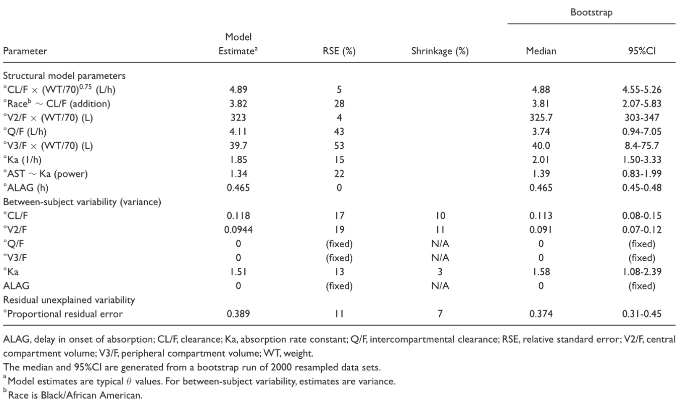

EGFRCL = THETA(1)

; exponents for covariates
TVCL = THETA(2)
CL = TVCL * (eGFR/90)**EGFRCL * EXP(ETA(1))
TVV1 = THETA(3)
V1 = TVV1 * EXP(ETA(2))
TVV2 = THETA(4)
V2 = TVV2
TVQ = THETA(5)

parameter_statistics
,mean,median,bias,stderr,RSE
EPS,,,,,
OMEGA_2_2,,,,,
THETA_1, 1.5931384100000001,1.588825,0.003918410000000039,0.10744291234222102,0.06744104069540387
THETA_2,,,,,
THETA_3,,,,,
THETA_4,,,,,
THETA_5,,,,,
THETA_6,,,,,
THETA_7,,,,,

8.334074465000002,8.330775,,0.5016889795794098,0.060197323852374494
__,56.330346999999996,56.188950000000006,,5.685406688374817,0.10092972955367766
___,43.85972335,43.89815,,2.5667781188750123,0.058522442068139766
____,20.53941255,20.4762,,1.480736053585409,0.0720924247458776
_____,0.041732263150000004,0.0415026,,0.005118015629468008,0.12263930214069897
______,0.8426534105000001,0.8410405,,0.048109367595793893,0.057092710948914965
_______,0.0952586309,0.09455745,,0.020658236954021983,0.21686472667981607
________,0.2736355495,0.2705565,,0.05567713249811053,0.20347185371142915
_________,0.04582427445000001,0.045739249999999995,,0.003907225931810612,0.08526541835537149

